CHAPTER 3
Reproductive Health
• Reproductive Health

The term simply refers to healthy reproductive organs with normal functions, but it has a broader perspective and includes the emotional and social aspects of reproduction also.
• According to the World Health Organisation (WHO), reproductive health means a total well-being in all aspects of reproduction, i.e., physical, emotional, behavioural and social. Therefore, a society with people having physically and functionally normal reproductive organs and normal emotional and behavioural interactions among them in all sex-related aspects might be called reproductively healthy.
3.1 | REPRODUCTIVE HEALTH -- PROBLEMS AND STRATEGIES

India moved early on reproductive health -- timeline as NCERT states:
• Programme launch -- 1951: India was amongst the first countries in the world (Summary: the first nation) to initiate action plans and programmes at national level to attain total reproductive health as a social goal -- these programmes, called family planning, were initiated in 1951 and periodically assessed over past decades.
• Current name: improved programmes covering wider reproduction-related areas now run as Reproductive and Child Health Care (RCH) programmes.
• Major tasks under RCH: creating awareness about reproduction-related aspects and providing facilities and support for a reproductively healthy society.
3.1 | Creating awareness

Under RCH, creating awareness is a major task. Different actors play distinct roles:
• Governmental and non-governmental agencies -- steps through audio-visual and print-media.
• Parents, close relatives, teachers, friends -- major role in dissemination of reproduction-related information.
• Schools -- sex education encouraged, gives right information and discourages myths and misconceptions about sex.
What information is given depends on the audience:
• Adolescent age group especially -- reproductive organs, adolescence and related changes, safe and hygienic sexual practices, STDs, AIDS -- to lead a reproductively healthy life.
• Fertile couples and those in marriageable age -- birth control options, care of pregnant mothers, post-natal care of mother and child, importance of breast feeding, equal opportunities for male and female child -- to bring up socially conscious healthy families of desired size.
• General society -- problems of uncontrolled population growth and social evils like sex-abuse and sex-related crimes -- to enable people to prevent them and build a socially responsible and healthy society.
3.1 | Infrastructure, programmes and research

Execution needs more than awareness -- it needs systems and science on the ground:
• Strong infrastructural facilities, professional expertise and material support -- to provide medical assistance and care for pregnancy, delivery, STDs, abortions, contraception, menstrual problems, infertility.
• Better techniques and new strategies from time to time -- for more efficient care; research on reproduction-related areas is encouraged and supported by governmental and non-governmental agencies -- to find out new methods and/or to improve upon the existing ones.
Two programmes NCERT singles out as examples of that infrastructure in action:
• Statutory ban on amniocentesis for sex-determination (source prints aminocentesis) -- legally checks the increasing menace of female foeticides.
• Massive child immunisation -- merits mention in this connection.
• Amniocentesis: some of the amniotic fluid of the developing foetus is taken to analyse the fetal cells and dissolved substances. This procedure is used to test for the presence of certain genetic disorders such as down syndrome, haemophilia, sickle-cell anemia, etc., and to determine the survivability of the foetus -- the source sentence prints haemoplilia for haemophilia and is garbled, reproduced here with the correct term.
[NOTE] Saheli -- a new oral contraceptive for the females -- was developed by scientists at Central Drug Research Institute (CDRI) in Lucknow, India.

That the system works is visible in outcome indicators:
• Better awareness about sex-related matters -- up.
• Medically assisted deliveries -- increased in number.
• Better post-natal care -- decreased MMR and IMR.
• Couples with small families -- increased in number.
• Better detection and cure of STDs -- better.
• Overall medical facilities for all sex-related problems -- increased.
• Assistance to infertile couples -- added in Summary as an extra indicator.
3.2 | POPULATION STABILISATION AND BIRTH CONTROL

In the last century an all-round development in various fields significantly improved the quality of life of the people.
3.2 | A century of population growth

The last century's all-round development plus increased health facilities and better living conditions had an explosive impact on population growth.
Population (millions) | 1900 / independence | 2000 | 2011
World | around 2 billion (2000 million) | about 6 billion | 7.2 billion
India | approximately 350 million at independence | close to the billion mark | crossed 1.2 billion in May 2011

Why it exploded -- probable reasons NCERT lists:
• Rapid decline in death rate, maternal mortality rate (MMR) and infant mortality rate (IMR).
• Increase in number of people in reproducible age.
Through the RCH programme the growth rate was brought down, but only marginally -- 2011 census: less than 2 per cent (20/1000/year) -- still a rapid increase that could lead to absolute scarcity of food, shelter and clothing despite progress.
3.2 | Steps to stabilise the population

Faced with explosive growth, the government was forced to act:
1 | Most important step -- motivate smaller families by using various contraceptive methods.
2 | Carry the message via advertisements in media, posters/bills showing a happy couple with two children -- Hum Do Hamare Do (we two, our two); many young, urban, working couples have even adopted an 'one child norm'.
3 | Statutory raising of marriageable age: female to 18 years, male to 21 years.
4 | Incentives given to couples with small families.

3.2 | What makes an ideal contraceptive

• An ideal contraceptive should be user-friendly, easily available, effective and reversible with no or least side-effects. It also should in no way interfere with the sexual drive, desire and/or the sexual act of the user.
A wide range of contraceptive methods are presently available which could be broadly grouped into the following categories, namely Natural/Traditional, Barrier, IUDs, Oral contraceptives, Injectables, Implants and Surgical methods. The table below compares them; the sections that follow give the details named in it.
Category | Principle / How it works | Key examples and notes
Natural / Traditional | Avoid chances of ovum and sperms meeting; no medicines or devices; side effects almost nil but chances of failure are also high | Periodic abstinence: avoid coitus day 10 to 17 when ovulation could be expected -- the fertile period. Withdrawal / coitus interruptus: male withdraws penis before ejaculation to avoid insemination. Lactational amenorrhea (absence of menstruation): ovulation does not occur during intense lactation after parturition; as long as mother breast-feeds fully, chances of conception are almost nil, but effective only upto six months after parturition
Barrier | Ovum and sperms prevented from physically meeting with barriers; available for both males and females | Condoms (Fig. 3.1a, b): thin rubber/latex sheath covering penis or vagina and cervix so ejaculated semen does not enter female tract; Nirodh is a popular male brand; protects also from STIs and AIDS; disposable, self-inserted, gives privacy. Diaphragms, cervical caps and vaults: rubber barriers covering cervix, blocking entry of sperms through cervix, reusable. Spermicidal creams, jellies and foams usually used alongwith barriers increase efficiency
IUDs | Inserted by doctors or expert nurses in uterus through vagina; increase phagocytosis of sperms and Cu ions suppress sperm motility and fertilising capacity; hormone-releasing IUDs also make uterus unsuitable for implantation and cervix hostile to sperms; ideal for spacing and delaying; most widely accepted in India | Non-medicated: Lippes loop; Copper-releasing: CuT, Cu7, Multiload 375; Hormone-releasing: Progestasert, LNG-20 (Fig. 3.2)
Oral contraceptives (pills) | Inhibit ovulation and implantation and alter quality of cervical mucus to prevent / retard entry of sperms; very effective with lesser side effects, well accepted | Progestogens or progestogen-estrogen combinations as tablets (pills): taken daily for 21 days starting preferably within first five days of menstrual cycle; after a gap of 7 days (menstruation occurs) repeat same pattern till desire to prevent conception. Saheli: non-steroidal, once a week pill with very few side effects and high contraceptive value
Injectables / Implants | Mode similar to pills; effective periods much longer | Progestogens alone or in combination with estrogen as injections or implants under the skin (Fig. 3.3)
Emergency contraception | Within 72 hours of coitus, very effective after rape or casual unprotected intercourse | Progestogens or progestogen-estrogen combinations or IUDs within 72 hours
Surgical (sterilisation) | Blocks gamete transport and prevents conception; highly effective but reversibility very poor; generally advised as terminal method to prevent any more pregnancies | Male - vasectomy and female - tubectomy. Vasectomy: small part of vas deferens is removed or tied up through small incision on scrotum (Fig. 3.4a) -- Vas deferens tied and cut. Tubectomy: small part of fallopian tube is removed (Fig. 3.4b) or tied up through incision in abdomen or through vagina -- Fallopian tubes tied and cut

3.2 | Natural and traditional methods

Principle: avoid chances of ovum and sperms meeting -- no medicines or devices involved.
Method | How it is practised | Key timing / limit
Periodic abstinence | Couples avoid coitus day 10 to 17 of menstrual cycle when ovulation could be expected -- the fertile period (very high chance of fertilisation) | Fertile window 10-17
Withdrawal / coitus interruptus | Male withdraws penis just before ejaculation so as to avoid insemination | --
Lactational amenorrhea (absence of menstruation) | Based on ovulation not occurring during intense lactation after parturition; as long as mother breast-feeds fully, chances almost nil | Effective only upto 6 months following parturition

Trade-off: no medicines or devices so side effects almost nil, but chances of failure are also high.
3.2 | Barrier methods

Principle: ovum and sperms prevented from physically meeting with help of barriers -- available for both males and females.
Barrier | What it is / how used | Extra facts
Condoms (Fig. 3.1a, b) -- thin rubber/latex sheath | Cover penis in male or vagina and cervix in female just before coitus so ejaculated semen does not enter female tract | Nirodh popular male brand; protects from STIs and AIDS -- use increased in recent years; disposable, self-inserted, gives privacy
Diaphragms, cervical caps and vaults -- rubber, cover cervix | Inserted into female tract to cover cervix during coitus; blocks entry of sperms through cervix | Reusable
Spermicidal creams, jellies and foams | Usually used alongwith barriers | Increase contraceptive efficiency

3.2 | Intra-uterine devices (IUDs)

Inserted by doctors or expert nurses in uterus through vagina -- one of the most widely accepted methods in India, ideal for delaying and spacing.
IUD type | Examples (Fig. 3.2) | How it works
Non-medicated | Lippes loop | Increase phagocytosis of sperms within uterus
Copper-releasing | CuT, Cu7, Multiload 375 | Cu ions suppress sperm motility and fertilising capacity
Hormone-releasing | Progestasert, LNG-20 | Make uterus unsuitable for implantation and cervix hostile to sperms (in addition to phagocytosis)

3.2 | Oral contraceptives, injectables, implants and emergency contraception

Method | Composition / delivery | Schedule and action
Oral pills -- progestogens or progestogen-estrogen combinations as tablets | Popularly called pills; Saheli -- non-steroidal, once a week, very few side effects, high contraceptive value | Take daily for 21 days starting preferably within first 5 days of menstrual cycle; gap 7 days (menstruation) then repeat; inhibit ovulation and implantation and alter cervical mucus to prevent/retard sperm entry; very effective, lesser side effects, well accepted
Injectables / Implants -- progestogens alone or with estrogen | As injections or implants under the skin (Fig. 3.3) | Mode similar to pills but effective periods much longer
Emergency contraception | Progestogens or progestogen-estrogen combinations or IUDs | Within 72 hours of coitus -- very effective after rape or casual unprotected intercourse

3.2 | Surgical methods -- sterilisation

Surgical methods, also called sterilisation, are generally advised for the male/female partner as a terminal method to prevent any more pregnancies. Surgical intervention blocks gamete transport and thereby prevent conception. Sterilisation procedure in the male is called vasectomy and that in the female, tubectomy.
1 | Vasectomy: a small part of the vas deferens is removed or tied up through a small incision on the scrotum (Figure 3.4a) -- Vas deferens tied and cut.
2 | Tubectomy: a small part of the fallopian tube is removed (Figure 3.4b) or tied up through a small incision in the abdomen or through vagina -- Fallopian tubes tied and cut.

These techniques are highly effective but their reversibility is very poor.
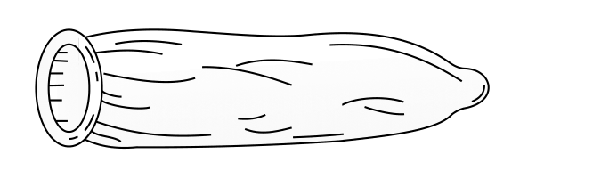 | 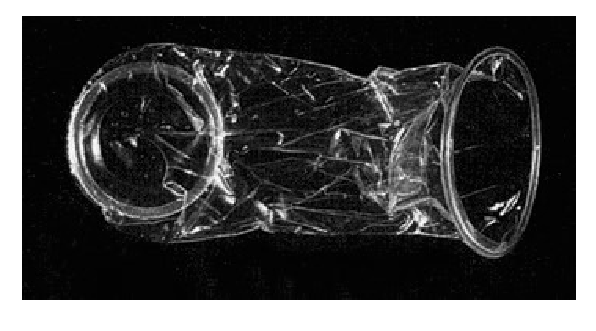

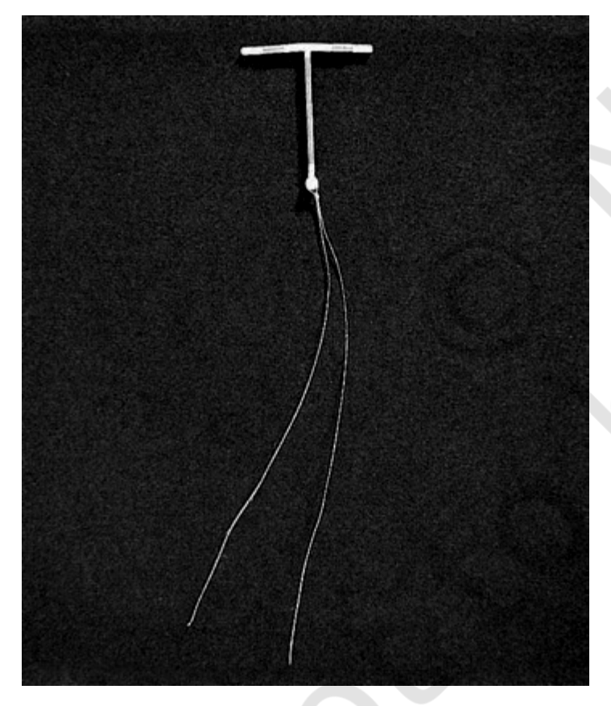 | 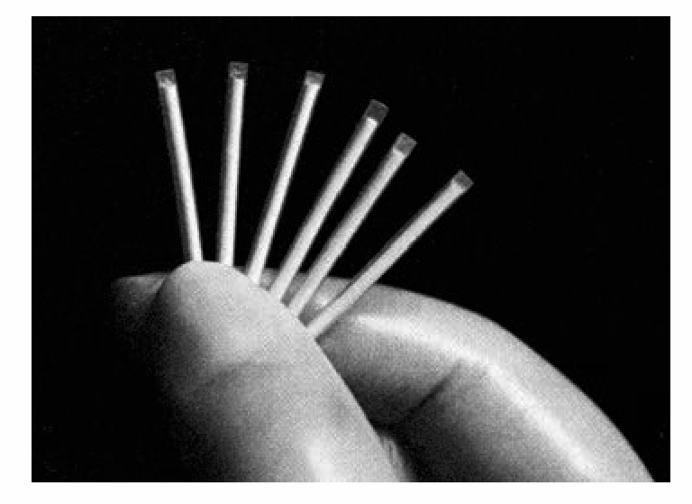

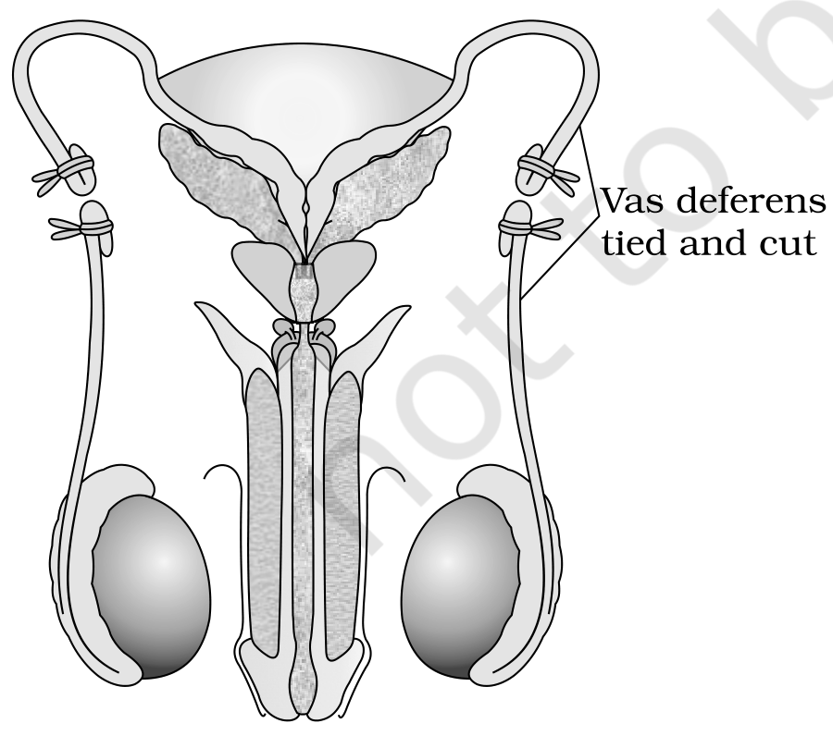 | 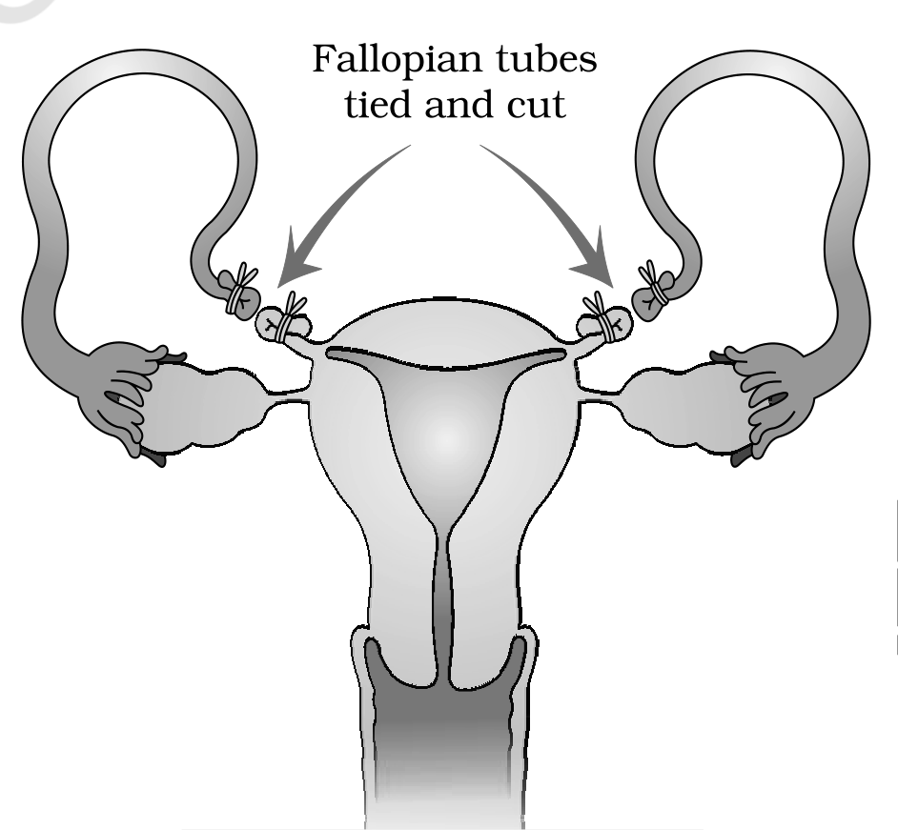

Putting contraception in perspective -- NCERT caveats at the end of 3.2:
• Who decides: selection and use should always be in consultation with qualified medical professionals.
• Nature: not regular requirements for maintenance of reproductive health; practiced against a natural event -- conception/pregnancy; one is forced to use them either to prevent or to delay/space pregnancy due to personal reasons.
• Population role: widespread use has significant role in checking uncontrolled growth of population.
• Caution -- possible ill-effects: nausea, abdominal pain, breakthrough bleeding, irregular menstrual bleeding or even breast cancer -- though not very significant, should not be totally ignored.
[MEMORY AID - not in NCERT] Recall the seven NCERT contraceptive groups in order: N-B-I-O-I-I-S -- Natural, Barrier, IUDs, Oral pills, Injectables, Implants, Surgical. Timings: pills 21 + 7 days, emergency 72 hours, lactational cover only 6 months.

3.3 | MEDICAL TERMINATION OF PREGNANCY (MTP)

• Intentional or voluntary termination of pregnancy before full term is called medical termination of pregnancy (MTP) or induced abortion -- the opener defines the term used in its own section heading.
• Global scale: nearly 45 to 50 million MTPs per year worldwide = 1/5th of total conceived pregnancies; whether to accept/legalise is debated in many countries for emotional, ethical, religious and social issues.
• Indian law: Government of India legalised MTP in 1971 with strict conditions to avoid misuse; restrictions important to check indiscriminate and illegal female foeticides reported high in India.
3.3 | Why MTP, and when it is safest

• Why MTP? To get rid of unwanted pregnancies -- due to casual unprotected intercourse, failure of contraceptive used during coitus, or rapes; also essential where continuation could be harmful or even fatal to mother or foetus or both.
• When is it safest? Relatively safe during first trimester -- upto 12 weeks; second trimester abortions are much more risky.
• Majority of MTPs performed illegally by unqualified quacks -- not only unsafe but could be fatal.
• Misuse of amniocentesis to determine sex of unborn child -- frequently, if foetus found female, followed by MTP -- totally against what is legal; dangerous for young mother and foetus.
• Reversal: effective counselling to avoid unprotected coitus and on risk factors of illegal abortions, plus more health care facilities, could reverse these trends.
3.3 | The MTP (Amendment) Act, 2017

[NOTE] The Medical Termination of Pregnancy (Amendment) Act, 2017 was enacted by the government of India with the intension of reducing the incidence of illegal abortion and consequent maternal mortality and morbidity -- source prints intension for intention.

Under the Act, a pregnancy may be terminated on certain considered grounds and within strict time limits:
1 | Within the first 12 weeks of pregnancy, on the opinion of one registered medical practitioner.
2 | More than 12 weeks but fewer than 24 weeks, on the opinion of two registered medical practitioners, formed in good faith, that the required grounds exist.
3 | Ground (i): continuation of the pregnancy would involve a risk to the life of the pregnant woman or of grave injury to her physical or mental health.
4 | Ground (ii): there is a substantial risk that if the child were born, it would suffer from such physical or mental abnormalities as to be seriously handicapped.

3.4 | SEXUALLY TRANSMITTED INFECTIONS (STIs)

• Infections or diseases which are transmitted through sexual intercourse are collectively called sexually transmitted infections (STI) or venereal diseases (VD) or reproductive tract infections (RTI) -- the opener defines the term used in its own heading.
• Common examples (8 named): gonorrhoea, syphilis, genital herpes, chlamydiasis, genital warts, trichomoniasis, hepatitis-B and HIV leading to AIDS (the most discussed infection in recent years) -- among these HIV is most dangerous (Chapter 7).
• Other routes for hepatitis-B and HIV: also transmitted by sharing injection needles, surgical instruments with infected persons, transfusion of blood, or from infected mother to foetus.
• Curability: all except hepatitis-B, genital herpes and HIV are completely curable if detected early and treated properly.
3.4 | Symptoms, stigma and complications

• Early symptoms of most of these (minor): itching, fluid discharge, slight pain, swellings, etc., in genital region.
• Asymptomatic cases: infected females may often be asymptomatic and may remain undetected for long.
• Why timely treatment is deterred: absence or less significant early symptoms plus social stigma attached to STIs deter infected persons from timely detection and proper treatment.
• Late complications if untreated: pelvic inflammatory diseases (PID), abortions, still births, ectopic pregnancies, infertility or even cancer of reproductive tract -- STIs are a major threat to a healthy society; prevention / early detection and cure given prime consideration under RCH.
• Most vulnerable age group: all persons vulnerable but incidences very high among 15-24 years -- the age group to which you also belong.
3.4 | Prevention is possible

There is no reason to panic because prevention is possible -- three simple principles keep one free of these infections:
1 | Avoid sex with unknown partners/multiple partners.
2 | Always try to use condoms during coitus.
3 | In case of doubt, go to a qualified doctor for early detection and get complete treatment if diagnosed with infection.

3.5 | INFERTILITY

Aspect of infertility | What NCERT states
Why it matters | Discussion on reproductive health is incomplete without infertility
Definition | A large number of couples all over the world including India are infertile -- unable to produce children inspite of unprotected sexual co-habitation even after 2 years (2-year criterion from Summary)
Reasons -- could be many | Physical, congenital, diseases, drugs, immunological or even psychological
Who is blamed vs reality in India | Often female blamed for childless couple, but more often than not problem lies in male partner
Where help comes from | Specialised health care units (infertility clinics, etc.) could help in diagnosis and corrective treatment of some of these disorders and enable children; where not possible, assisted to have children through ART (assisted reproductive technologies)

3.5 | Assisted reproductive technologies

• In vitro fertilisation (IVF -- fertilisation outside the body in almost similar conditions as that in the body) followed by embryo transfer (ET) is one of such methods.
The lab route is best seen as a menu of cargos and destinations:
ART (what moves) | Cargo / source | Where it goes / how
IVF-ET: test tube baby programme | Ova from wife/donor (female) and sperms from husband/donor (male) collected and induced to form zygote under simulated lab conditions | ZIFT -- zygote or early embryos upto 8 blastomeres into fallopian tube; IUT -- embryos with more than 8 blastomeres into uterus, to complete its further development; in-vivo fertilised embryos also usable to assist females who cannot conceive
GIFT -- gamete intra fallopian transfer | Ovum collected from a donor | Transferred into fallopian tube of another female who cannot produce one but can provide suitable environment for fertilisation and further development
ICSI -- intra cytoplasmic sperm injection | A single sperm directly injected into an ovum | Embryo formed in laboratory

3.5 | Artificial insemination and the limits of ART

• AI -- artificial insemination / IUI -- intra-uterine insemination: for infertility due to inability of male partner to inseminate the female or very low sperm counts in the ejaculates -- semen from husband or healthy donor artificially introduced into vagina or uterus (IUI) of female.
Why ART does not reach everyone:
• Technical: extremely high precision handling by specialised professionals and expensive instrumentation required.
• Access: presently available only in very few centres in the country; affordable to only a limited number of people.
• Acceptance: emotional, religious and social factors are deterrents in adoption.
[NOTE] ZIFT vs IUT is a numbers test: ZIFT -- zygote or early embryo upto 8 blastomeres -- into the fallopian tube; IUT -- embryos with more than 8 blastomeres -- into the uterus. GIFT transfers an unfertilised ovum, IVF transfers an embryo, ICSI injects a single sperm into a single ovum, and IUI introduces semen into the uterus -- four different cargos, four different names.

3.5 | Adoption as an alternative

Since the ultimate aim of all these procedures is to have children, in India we have so many orphaned and destitute children, who would probably not survive till maturity, unless taken care of. Our laws permit legal adoption and it is as yet, one of the best methods for couples looking for parenthood.
QR | QUICK RECAP

• Reproductive health is total well-being -- physical, emotional, behavioural and social (WHO). India was amongst the first countries / the first nation to launch RCH programmes (family planning, 1951). The work is awareness (audio-visual, print, parents/teachers, sex education) plus medical care for pregnancy, delivery, STDs, contraception, menstrual problems and infertility, supported by infrastructure, expertise, research and laws such as the ban on amniocentesis for sex determination. Indicators of improvement are lower MMR/IMR, more small families, better STD cure, more medical facilities and assistance to infertile couples -- plus Saheli from CDRI, Lucknow.
• Population: better health and living conditions drove an explosion -- world 2 billion (1900) to 6 billion (2000) to 7.2 billion (2011); India about 350 million at independence to near a billion by 2000 to over 1.2 billion in May 2011. Reasons: fall in death rate, MMR, IMR and more people in reproducible age. RCH cut growth only marginally to less than 2% (20/1000/year, 2011), threatening food, shelter, clothing scarcity. Response: motivate smaller families -- Hum Do Hamare Do, one-child norm, marriage age 18 (F) / 21 (M), incentives.
• Contraception -- seven NCERT groups: an ideal contraceptive is user-friendly, easily available, effective, reversible, least side effects and does not interfere with the sexual act. Natural -- avoid ovum-sperm meeting without devices: periodic abstinence day 10-17 (fertile period), withdrawal, lactational amenorrhea (intense lactation, 6 months only, almost nil side effects but high failure). Barrier -- physically block meeting: condoms (Nirodh, also protects from STIs/AIDS, disposable, private), diaphragms/caps/vaults (reusable) plus spermicidal creams/jellies/foams. IUDs by doctors / nurses through vagina: Lippes loop, CuT/Cu7/Multiload 375, Progestasert/LNG-20 via phagocytosis, Cu suppression, hormone making uterus unsuitable and cervix hostile; ideal for spacing, most widely accepted in India. Pills -- progestogen or progestogen-estrogen 21 days within first 5 days, 7-day gap, inhibit ovulation/implantation and alter cervical mucus; well accepted, plus Saheli weekly, non-steroidal. Injectables/implants under skin, similar mode but much longer action. Emergency within 72 hours after rape or casual unprotected intercourse. Surgical sterilisation blocks gamete transport -- vasectomy (Vas deferens tied and cut) and tubectomy (Fallopian tubes tied and cut), highly effective, poorly reversible -- always chosen with a qualified doctor. Contraception is against natural conception, used only to prevent / delay / space pregnancy, and possible ill-effects (nausea, bleeding, breast cancer) though not very significant should not be ignored.
• MTP: intentional / voluntary termination before full term (induced abortion); 45-50 million per year = 1/5th of conceived pregnancies; debated for emotional, ethical, religious, social reasons; legal in India since 1971 with strict conditions to check illegal female foeticide; needed for unwanted pregnancies (casual / failed contraception / rape) or harm to mother / foetus; relatively safe upto 12 weeks, riskier in second trimester; majority illegal by quacks, unsafe / fatal; amniocentesis misused for sex determination leading to female foeticide, dangerous for mother and foetus; reversible only by counselling, avoiding unprotected coitus and more health facilities. Amendment Act, 2017 aims to cut illegal abortion / mortality: within 12 weeks -- one doctor; 12-24 weeks -- two doctors; grounds: risk to life / grave injury to physical / mental health, or substantial risk of serious physical / mental handicap in the child.
• STIs: infections transmitted by sexual intercourse -- STI / VD / RTI: gonorrhoea, syphilis, genital herpes, chlamydiasis, genital warts, trichomoniasis, hepatitis-B, HIV leading to AIDS (most dangerous, Chapter 7); hepatitis-B / HIV also spread by needles, surgical instruments, blood transfusion, mother to foetus; all except hepatitis-B, genital herpes and HIV are completely curable if early and properly treated; minor early symptoms -- itching, discharge, pain, swelling; females often asymptomatic; absent/less symptoms plus stigma deter timely treatment leading to PID, abortions, still births, ectopic pregnancies, infertility, reproductive-tract cancer; major threat, prevention / early cure is prime under RCH; highest incidence 15-24 years; prevention: avoid unknown / multiple partners, use condoms, see a qualified doctor if in doubt and complete treatment.
• Infertility -- inability to produce children inspite of unprotected co-habitation even after 2 years; many causes -- physical, congenital, diseases, drugs, immunological, psychological; female often blamed but more often male partner is responsible; infertility clinics help diagnosis / corrective treatment, but where not possible, ART assists: IVF-ET (test tube baby) -- ova and sperms collected, zygote formed in lab under simulated conditions; ZIFT (upto 8 blastomeres) to fallopian tube, IUT (more than 8) to uterus; in-vivo embryos also usable; GIFT -- donor ovum into another female's fallopian tube; ICSI -- single sperm directly into ovum; AI -- inability to inseminate or very low counts corrected by introducing husband / donor semen into vagina or uterus (IUI); all require high precision, expensive instrumentation, available in very few centres, affordable to limited people, deterred by emotional / religious / social factors; many orphaned / destitute children unlikely to survive without care -- legal adoption is as yet one of the best methods for parenthood.
EX | TERMS USED IN THE EXERCISES

A few end-of-chapter questions lean on a term or task the body states only indirectly. Each is closed below using only facts from this chapter.
Exercise term / task | Explanation from this chapter
Q7 -- Why removal of gonads is not a contraceptive option | The chapter's surgical methods are sterilisation by blocking gamete transport -- Vas deferens tied and cut (vasectomy) and Fallopian tubes tied and cut (tubectomy); they do not remove the gonads, and reversibility is already very poor. The chapter never lists gonad removal among its seven contraceptive categories, and permanent removal violates the ideal-contraceptive criteria of reversibility and no interference with normal physiology. Hence gonad removal is not a contraceptive option.
Q11(a) -- Abortions can happen spontaneously -- True | The chapter defines only intentional / voluntary termination (MTP / induced abortion), but it also lists abortion as a complication of STIs / PID that occurs without any MTP procedure, which shows pregnancy loss can happen on its own. Spontaneous abortion (miscarriage) is therefore true.
Q12(c) -- Oral pills are not especially popular among rural women -- False to correct | The chapter states only that pills are very effective with lesser side effects and are well accepted by the females and that Saheli is a once-a-week pill, but it never distinguishes rural from urban users. In fact, IUDs are described as one of the most widely accepted methods in India, so singling out pills as rural-popular is not supported.

